LOCKEDME OUTPUT

1)WELCOME PAGE & CHOOSE MAIN MENU 1)RETRIVING FILES

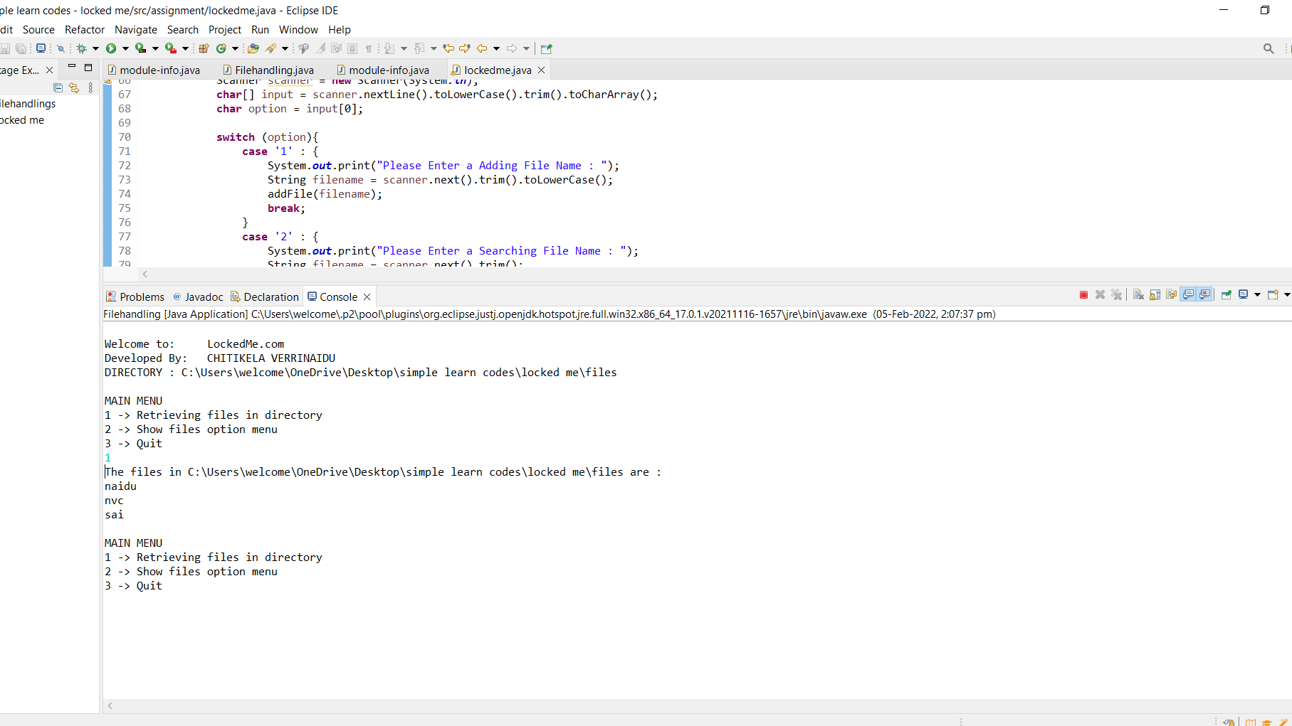

2)SHOW FILES OPTION MENU

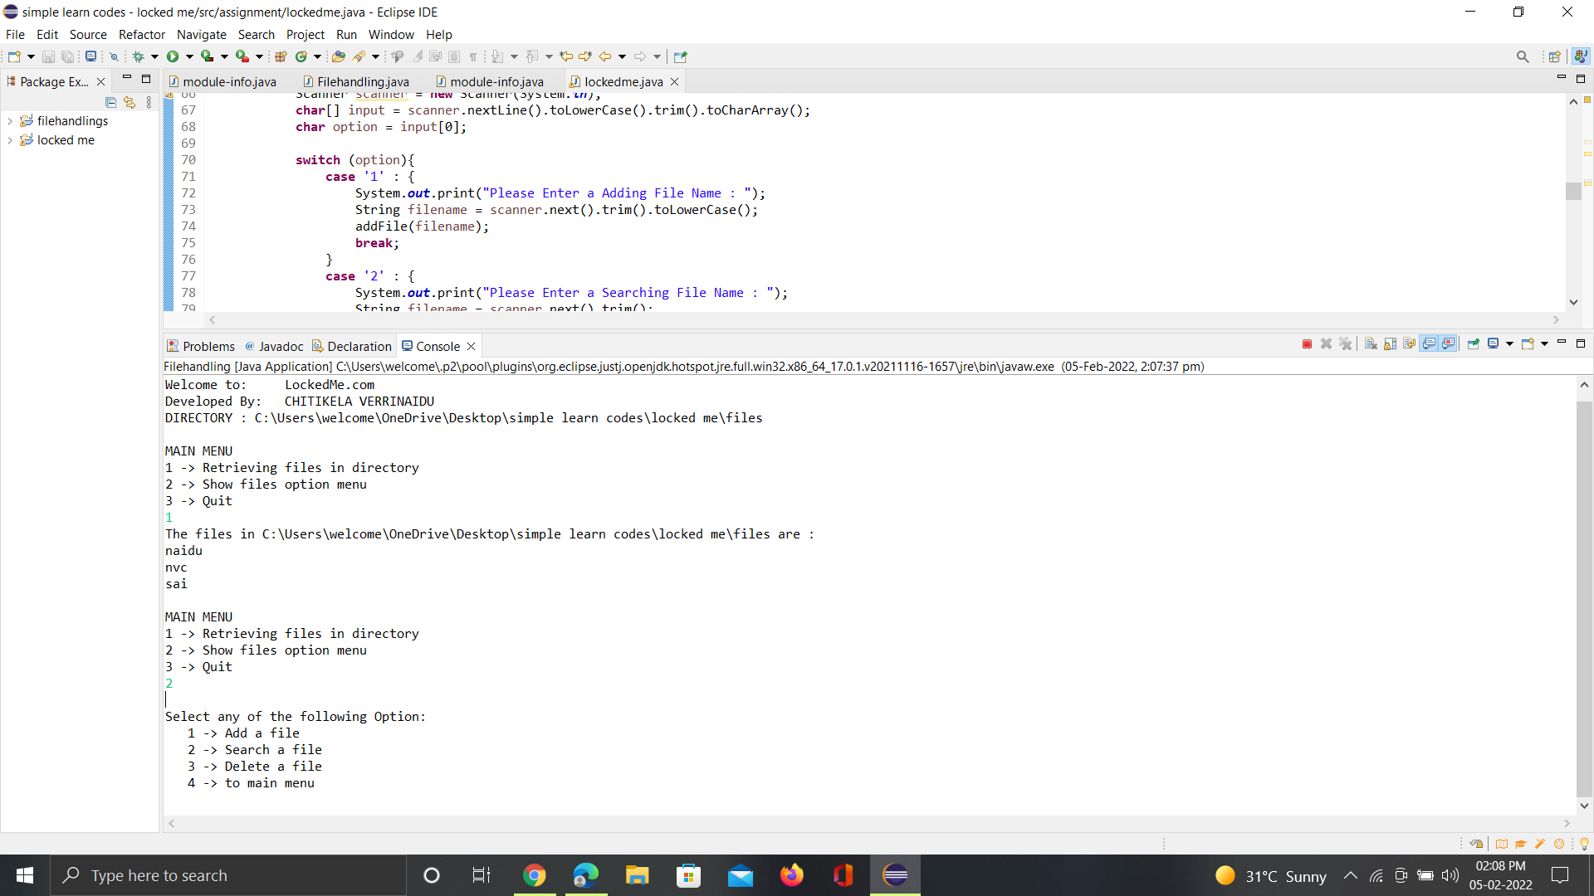

3)ADDING A FILE

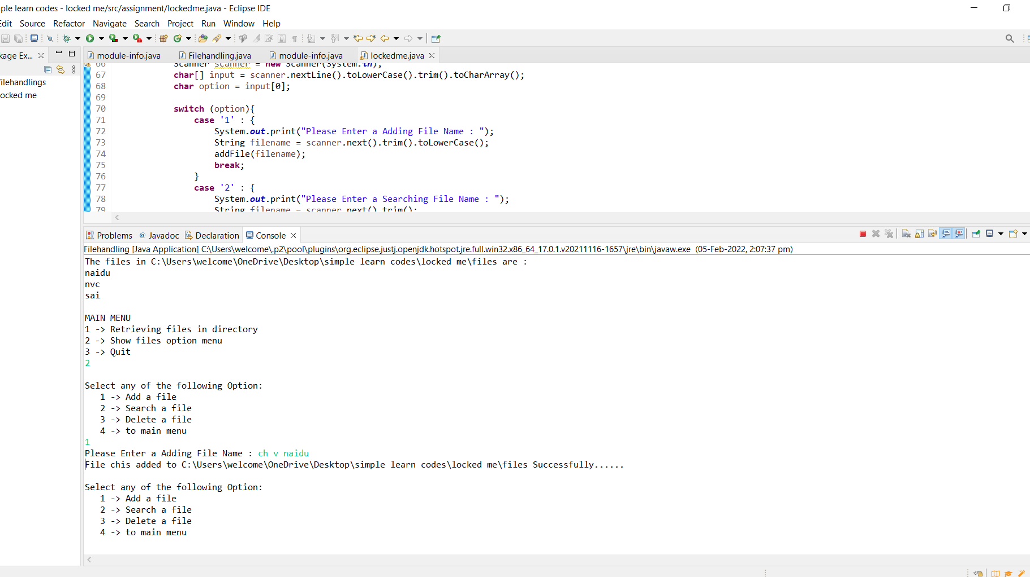

4)SEARCHING FILE

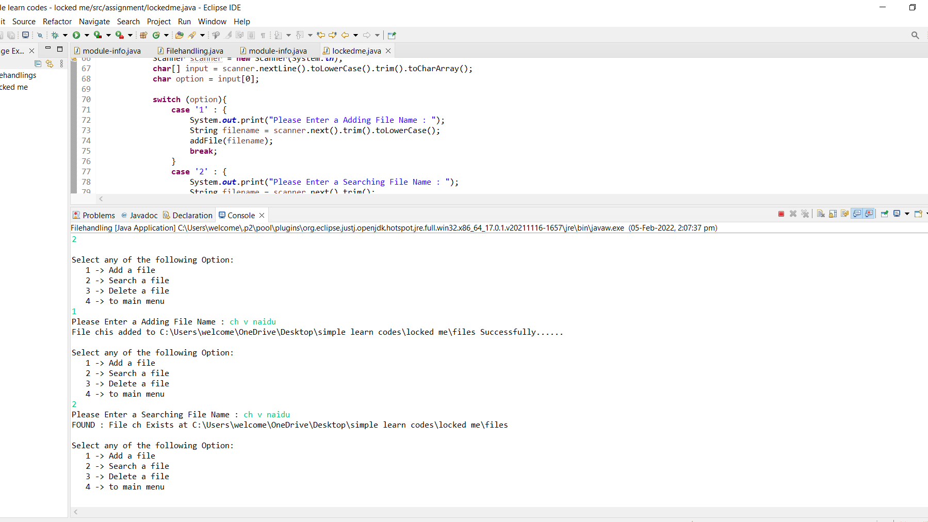

5)DELETING A FILE

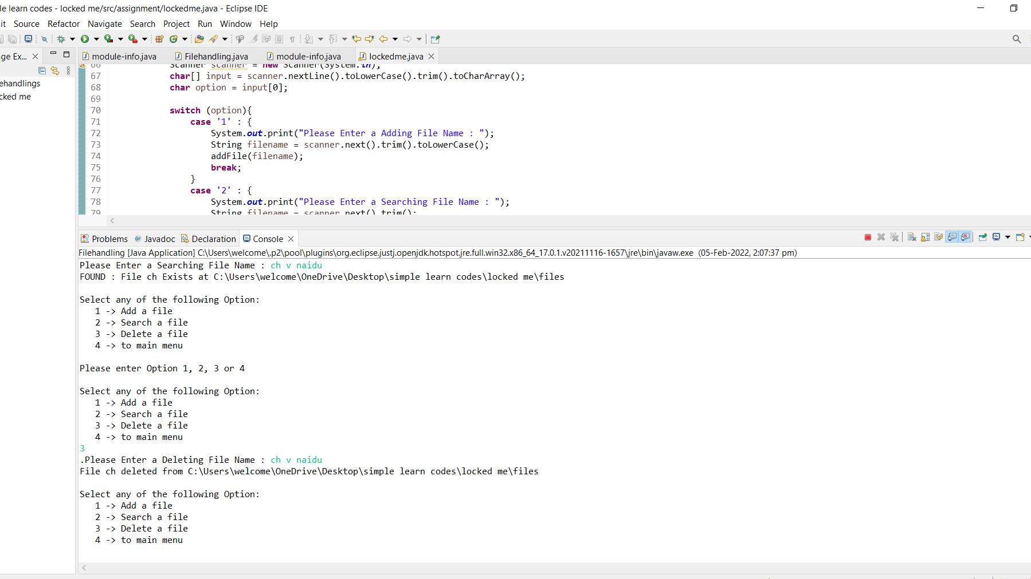

6)TAKE TO MAIN MENU

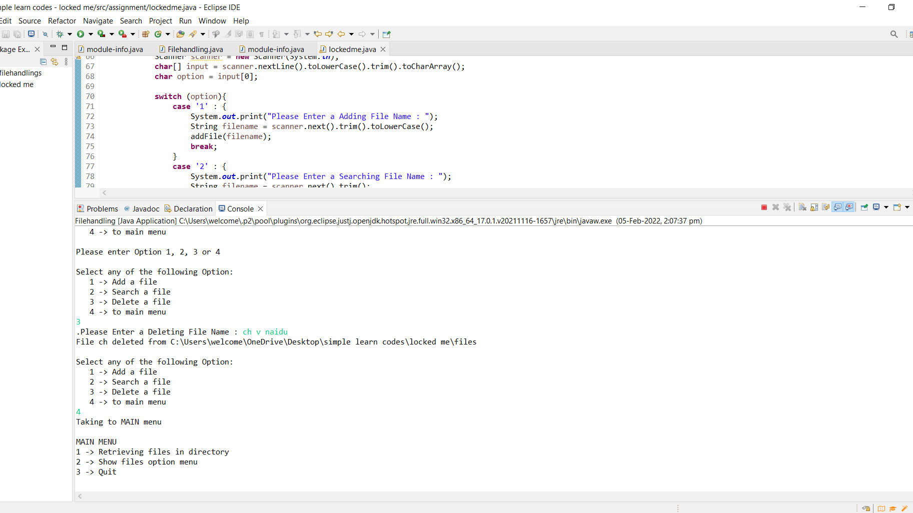

7)QUIT THE PROGRAM

